1. Mutational Spectrum of Actinopterygii versus temperature and longevity (Time of maturation):
   1. **All nominally significant spearman rank correlations between frequencies of 4 transitions and temperature:**

|  |
| --- |
| **N = 128**   * data: TemperMut$T_C and TemperMut$Temperature   S = 474663, p-value = 3.321e-05  alternative hypothesis: true rho is not equal to 0  sample estimates:  **rho**  **-0.3581037**   * data: TemperMut$A_G and TemperMut$Temperature   S = 256954, p-value = 0.002522  alternative hypothesis: true rho is not equal to 0  sample estimates:  **rho**  **0.2648037**   * data: allparameters$AGdividedTC and allparameters$Temperature   S = 179782, p-value = 1.654e-07  alternative hypothesis: true rho is not equal to 0  sample estimates:  **rho**  **0.447675**   * **other transitions give p-value >0,1** |

* 1. **PICs:**

|  |
| --- |
| Coefficients:  Estimate Std. Error t value Pr(>|t|)  (Intercept) -0.961202 2.371449 -0.405 0.687  pic(data$Temperature, tree_pruned) -0.005479 0.091820 -0.060 0.953  pic(data$Tm, tree_pruned) 0.110200 0.127524 0.864 0.392 |

* 1. **Multiple models between temperature and fractions of AH>GH + TH>CH:**

|  |
| --- |
| **N=128**   * lm(formula = Temperature ~ scale(T_C) + scale(A_G), data = allparameters)   (Intercept) 17.2395 0.6029 28.594 < 2e-16 ***  scale(A_G) 1.6769 0.6097 2.750 0.006835 **  scale(T_C) -2.4375 0.6097 -3.998 0.000109 ***  Residual standard error: 6.821 on 125 degrees of freedom  Multiple R-squared: 0.1753, Adjusted R-squared: 0.1621  F-statistic: 13.28 on 2 and 125 DF, p-value: 5.869e-06  **N=65**   * lm(formula = Temperature ~ scale(T_C) + scale(A_G), data = allparameters)   (Intercept) 15.9015 0.8532 18.638 < 2e-16 ***  scale(A_G) 2.9136 0.8660 3.364 0.00132 **  scale(T_C) -1.5153 0.8660 -1.750 0.08511 .  Residual standard error: 6.879 on 62 degrees of freedom  Multiple R-squared: 0.2053, Adjusted R-squared: 0.1796  F-statistic: 8.007 on 2 and 62 DF, p-value: 0.0008065 |

* 1. 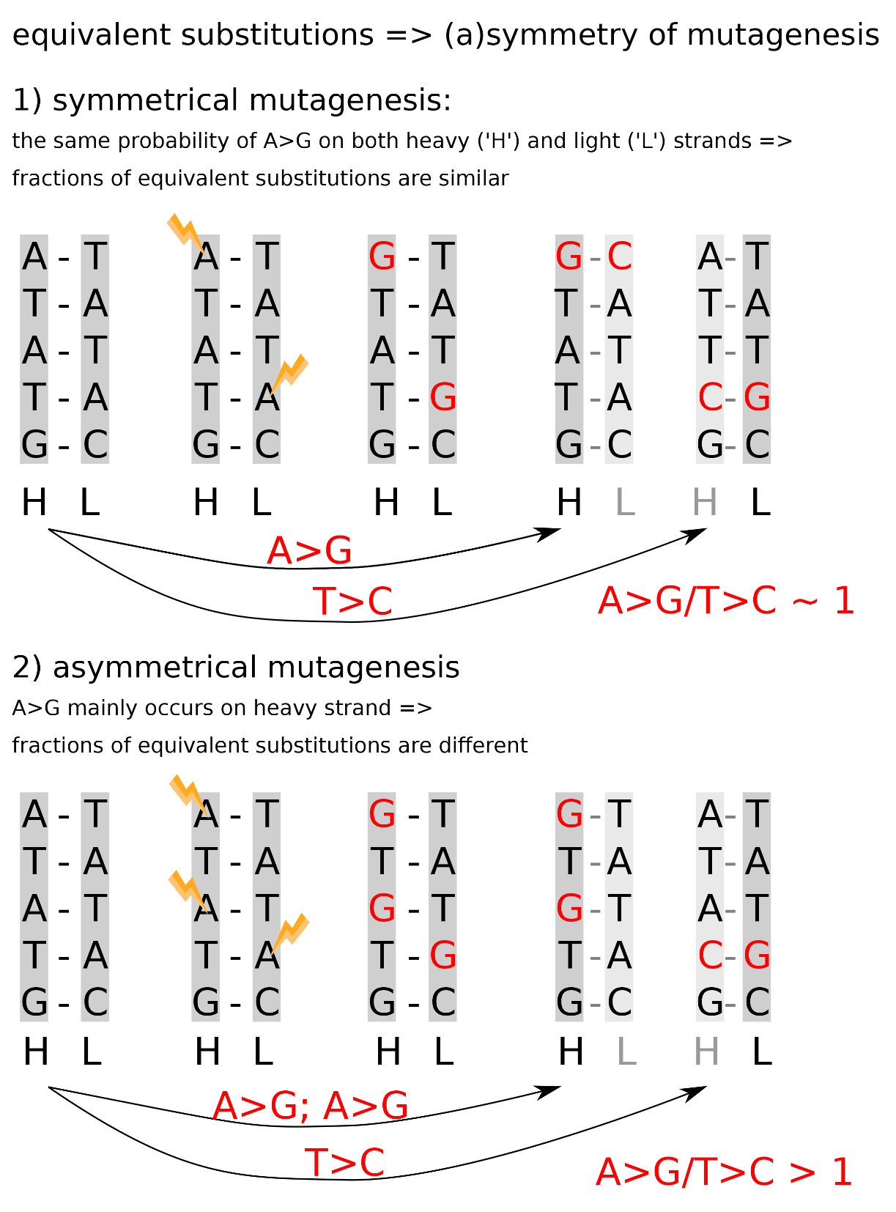**Asymmetry of equivalent substitutions traces chemical damage:**

If a mutagenic process introduces for example mutation A>G on one chain it will be equivalent to T>C on opposite chain and thus symmetrical mutagenesis would lead to similar probabilities of A>G and T>C on any chain. However, probabilities are not equal with AH>GH being significantly higher than TH>CH (Fig 1A). This means that a mutagen, such as a high temperature, affects predominantly heavy chain, which stays single-stranded during mtDNA replication, introducing AH>GH substitutions and the increased temperature is associated with even more elevated asymmetry: AH>GH /TH>CH.

We interpret their increased asymmetry of AH>GH /TH>CH  in warm-water species as increased chemical damage of the heavy chain of mtDNA. The logic behind this is following: both these substitutions AH>GH and TH>CH are equivalent, in terms that they are complementary to each other on opposite strands: AH>GH  correspond to TL>CL, while TH>CH  correspond to AL>GL (see Supplementary Mat.); if mtDNA is mutated mainly on a heavy strand (AH>GH will occur mostly on a heavy strand) the ratio of AH>GH /TH>CH will be more than 1.

* 1. **All multiple models between fractions of AH>GH and TH>CH and temperature + longevity:**

|  |
| --- |
| **N=65**   * lm(formula = A_G ~ scale(Temperature) * scale(Tm), data = allparameters)   (Intercept) 0.131507 0.008055 16.325 < 2e-16 ***  scale(Temperature) 0.024866 0.008083 3.076 0.00313 **  scale(Tm) -0.008903 0.008722 -1.021 0.31142  scale(Temperature):scale(Tm) -0.000811 0.009005 -0.090 0.92854  Residual standard error: 0.062 on 61 degrees of freedom  Multiple R-squared: 0.1815, Adjusted R-squared: 0.1412  F-statistic: 4.508 on 3 and 61 DF, p-value: 0.006387   * lm(formula = A_G ~ scale(Temperature) + scale(Tm), data = allparameters)   (Intercept) 0.131723 0.007628 17.269 < 2e-16 ***  scale(Temperature) 0.024931 0.007985 3.122 0.00273 **  scale(Tm) -0.008600 0.007985 -1.077 0.28564  Residual standard error: 0.0615 on 62 degrees of freedom  Multiple R-squared: 0.1814, Adjusted R-squared: 0.1549  F-statistic: 6.867 on 2 and 62 DF, p-value: 0.002023   * lm(formula = A_G ~ scale(Temperature), data = allparameters)   (Intercept) 0.131723 0.007637 17.247 < 2e-16 ***  scale(Temperature) 0.027259 0.007697 3.542 0.000755 ***  Residual standard error: 0.06158 on 63 degrees of freedom  Multiple R-squared: 0.166, Adjusted R-squared: 0.1528  F-statistic: 12.54 on 1 and 63 DF, p-value: 0.0007547   * lm(formula = T_C ~ scale(Temperature) + scale(Tm), data = allparameters)   (Intercept) 0.068819 0.006021 11.430 <2e-16 ***  scale(Temperature ) -0.014254 0.006303 -2.261 0.0273 *  scale(Tm) -0.007483 0.006303 -1.187 0.2397  Residual standard error: 0.04854 on 62 degrees of freedom  Multiple R-squared: 0.08108, Adjusted R-squared: 0.05144  F-statistic: 2.735 on 2 and 62 DF, p-value: 0.07271   * lm(formula = T_C ~ scale(Temperature), data = allparameters)   (Intercept) 0.068819 0.006041 11.393 <2e-16 ***  scale(Temperature) -0.012228 0.006088 -2.009 0.0489 *  Residual standard error: 0.0487 on 63 degrees of freedom  Multiple R-squared: 0.06019, Adjusted R-squared: 0.04527  F-statistic: 4.035 on 1 and 63 DF, p-value: 0.04886 |

* 1. **All multiple models between AH>GH : TH>CH and temperature + longevity:**

|  |
| --- |
| **N=123 (no NULL in A_G and T_C)**   * lm(formula = log2(AGdivTC) ~ scale(Temperature), data = allparameters)   (Intercept) 1.2664 0.1194 10.607 < 2e-16 ***  scale(Temperature) 0.5674 0.1199 4.733 6.06e-06 ***  Residual standard error: 1.324 on 121 degrees of freedom  Multiple R-squared: 0.1562, Adjusted R-squared: 0.1492  F-statistic: 22.4 on 1 and 121 DF, p-value: 6.056e-06   * lm(formula = Temperature ~ scale(AGdivTC), data = allparameters)   (Intercept) 17.2793 0.6683 25.855 <2e-16 ***  scale(TCdivAG) 1.2923 0.6711 1.926 0.0565 .  Residual standard error: 7.412 on 121 degrees of freedom  Multiple R-squared: 0.02974, Adjusted R-squared: 0.02172  F-statistic: 3.709 on 1 and 121 DF, p-value: 0.05648  **N=62 (no NULL)**   * lm(formula = Temperature ~ scale(AGdivTC), data = allparameters)   (Intercept) 16.0129 0.9507 16.844 <2e-16 ***  scale(TCdivAG) 1.8008 0.9584 1.879 0.0651 .  Residual standard error: 7.486 on 60 degrees of freedom  Multiple R-squared: 0.05557, Adjusted R-squared: 0.03983  F-statistic: 3.53 on 1 and 60 DF, p-value: 0.06512   * lm(formula = log2(AGdivTC) ~ scale(Temperature) + scale(Tm),   data = allparameters)  (Intercept) 1.11377 0.16982 6.559 1.51e-08 ***  scale(Temperature) 0.58133 0.17790 3.268 0.00181 **  scale(Tm) 0.03231 0.17790 0.182 0.85649  Residual standard error: 1.337 on 59 degrees of freedom  Multiple R-squared: 0.1597, Adjusted R-squared: 0.1313  F-statistic: 5.608 on 2 and 59 DF, p-value: 0.005891 |

* 1. **All nominally significant spearman rank correlations between fractions of 4 transitions and longevity:**

|  |
| --- |
| **N=106**   * data: MATUTmmut$C_G and MATUTmmut$Tm   S = 242544, p-value = 0.0222  alternative hypothesis: true rho is not equal to 0  sample estimates:  **rho**  **-0.2219755** |

1. Whole genomes of Actinipterygii versus temperature and longevity (Time of maturation):
   1. **All nominally significant spearman rank correlations between fractions of 4 nucleotides and temperature:**

|  |
| --- |
| * data: log2(SynNuc$Temperature) and SynNuc$FrT   S = 5335566, p-value = 0.03301  alternative hypothesis: true rho is not equal to 0  sample estimates:  **rho**  **0.1172215**   * data: log2(SynNuc$Temperature) and SynNuc$FrA   S = 6966996, p-value = 0.005369  alternative hypothesis: true rho is not equal to 0  sample estimates:  **rho**  **-0.1527014**   * data: log2(SynNuc$Temperature) and SynNuc$FrC   S = 7546431, p-value = 4.711e-06  alternative hypothesis: true rho is not equal to 0  sample estimates:  **rho**  **-0.2485698**   * data: log2(SynNuc$Temperature) and SynNuc$FrG   S = 5248321, p-value = 0.01655  alternative hypothesis: true rho is not equal to 0  sample estimates:  **rho**  **0.1316563** |

* 1. **All multiple models between STG-SAC and temperature + longevity:**

|  |
| --- |
| * lm(formula = AC_TGSkew ~ log2(Temperature + 2) + log2(Tm), data = SynNuc)   (Intercept) 0.140140 0.043625 3.212 0.00167 **  log2(Temperature + 2) 0.056133 0.009553 5.876 3.42e-08 ***  log2(Tm) 0.024618 0.006086 4.045 8.99e-05 ***  Residual standard error: 0.08634 on 128 degrees of freedom  (4973 observations deleted due to missingness)  Multiple R-squared: 0.24, Adjusted R-squared: 0.2282  F-statistic: 20.22 on 2 and 128 DF, p-value: 2.346e-08   * lm(formula = AC_TGSkew ~ scale(Temperature + 2) + scale(Tm),   data = SynNuc)  (Intercept) 0.421980 0.007940 53.148 < 2e-16 ***  scale(Temperature + 2) 0.045806 0.007493 6.113 1.10e-08 ***  scale(Tm) 0.026502 0.006590 4.022 9.82e-05 ***  Residual standard error: 0.08541 on 128 degrees of freedom  (4973 observations deleted due to missingness)  Multiple R-squared: 0.2563, Adjusted R-squared: 0.2447  F-statistic: 22.06 on 2 and 128 DF, p-value: 5.876e-09 |

* 1. **PICs**

|  |
| --- |
| # lambda [ ML] : 0.990  # Coefficients:  # Estimate Std. Error t value Pr(>|t|)  # (Intercept) 0.3185648 0.1248595 2.5514 0.01191 *  # log2(Temperature + 2) 0.0186083 0.0086042 2.1627 0.03242 *  # log2(Tm) 0.0099184 0.0048863 2.0298 0.04445 * |

* 1. **All multiple models between fraction of A and temperature + longevity:**

|  |
| --- |
| * lm(formula = FrA ~ scale(Temperature) + scale(Tm), data = SynNuc)   (Intercept) 0.224467 0.004409 50.908 < 2e-16 ***  scale(Temperature) -0.015662 0.004161 -3.764 0.000254 ***  scale(Tm) -0.006686 0.003660 -1.827 0.070052 .  Residual standard error: 0.04743 on 128 degrees of freedom  (4973 observations deleted due to missingness)  Multiple R-squared: 0.1051, Adjusted R-squared: 0.09109  F-statistic: 7.514 on 2 and 128 DF, p-value: 0.0008213   * lm(formula = FrA ~ log2(Temperature + 2) + log2(Tm), data = SynNuc)   (Intercept) 0.309754 0.024281 12.757 < 2e-16 ***  log2(Temperature + 2) -0.017552 0.005317 -3.301 0.00125 **  log2(Tm) -0.005453 0.003387 -1.610 0.10989  Residual standard error: 0.04806 on 128 degrees of freedom  (4973 observations deleted due to missingness)  Multiple R-squared: 0.08145, Adjusted R-squared: 0.0671  F-statistic: 5.675 on 2 and 128 DF, p-value: 0.004351   * lm(formula = FrA ~ log2(Temperature + 2) * log2(Tm), data = SynNuc)   (Intercept) 0.422770 0.050387 8.390 8.02e-14 ***  log2(Temperature + 2) -0.043535 0.011464 -3.798 0.000225 ***  log2(Tm) -0.055592 0.019986 -2.782 0.006234 **  log2(Temperature + 2):log2(Tm) 0.011796 0.004637 2.544 0.012156 *  Residual standard error: 0.04706 on 127 degrees of freedom  (4973 observations deleted due to missingness)  Multiple R-squared: 0.126, Adjusted R-squared: 0.1053  F-statistic: 6.102 on 3 and 127 DF, p-value: 0.0006525 |

* 1. **All multiple models between other fractions and temperature + longevity:**

|  |
| --- |
| * lm(formula = FrC ~ log2(Temperature + 2) + log2(Tm), data = SynNuc)   (Intercept) 0.120175 0.013771 8.727 1.2e-14 ***  log2(Temperature + 2) -0.010514 0.003016 -3.487 0.000671 ***  log2(Tm) -0.006856 0.001921 -3.568 0.000506 ***  Residual standard error: 0.02726 on 128 degrees of freedom  (4973 observations deleted due to missingness)  Multiple R-squared: 0.1307, Adjusted R-squared: 0.1172  F-statistic: 9.626 on 2 and 128 DF, p-value: 0.0001275   * lm(formula = FrT ~ log2(Temperature + 2) + log2(Tm), data = SynNuc)   (Intercept) 0.249276 0.026709 9.333 4.08e-16 ***  log2(Temperature + 2) 0.023023 0.005849 3.936 0.000135 ***  log2(Tm) 0.014498 0.003726 3.891 0.000160 ***  Residual standard error: 0.05286 on 128 degrees of freedom  (4973 observations deleted due to missingness)  Multiple R-squared: 0.1562, Adjusted R-squared: 0.143  F-statistic: 11.85 on 2 and 128 DF, p-value: 1.904e-05 |

* 1. **All multiple models between other nucleotide skews and temperature + longevity:**

|  |
| --- |
| * lm(formula = CtoTSkew ~ log2(Temperature + 2) + log2(Tm), data = SynNuc)   (Intercept) -0.39217 0.06129 -6.399 2.70e-09 ***  log2(Temperature + 2) -0.05852 0.01342 -4.361 2.64e-05 ***  log2(Tm) -0.03714 0.00855 -4.344 2.82e-05 ***  Residual standard error: 0.1213 on 128 degrees of freedom  (4973 observations deleted due to missingness)  Multiple R-squared: 0.1863, Adjusted R-squared: 0.1735  F-statistic: 14.65 on 2 and 128 DF, p-value: 1.866e-06   * lm(formula = GtoASkew ~ log2(Temperature + 2) + log2(Tm), data = SynNuc)   (Intercept) -0.006336 0.082967 -0.076 0.9392  log2(Temperature + 2) 0.043809 0.018168 2.411 0.0173 *  log2(Tm) 0.011212 0.011575 0.969 0.3345  Residual standard error: 0.1642 on 128 degrees of freedom  (4973 observations deleted due to missingness)  Multiple R-squared: 0.04399, Adjusted R-squared: 0.02905  F-statistic: 2.945 on 2 and 128 DF, p-value: 0.05618 |

1. Whole genomes of Mammals versus temperature and longevity (Generation length):
   1. 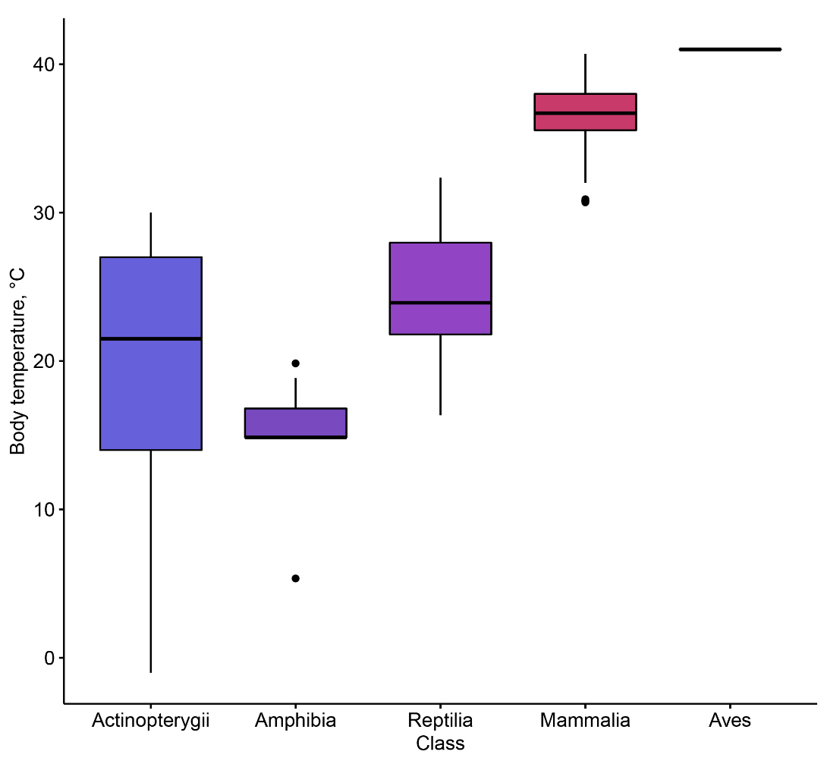**Average body temperature in Vertebrate classes (AnAge DB):**
   2. 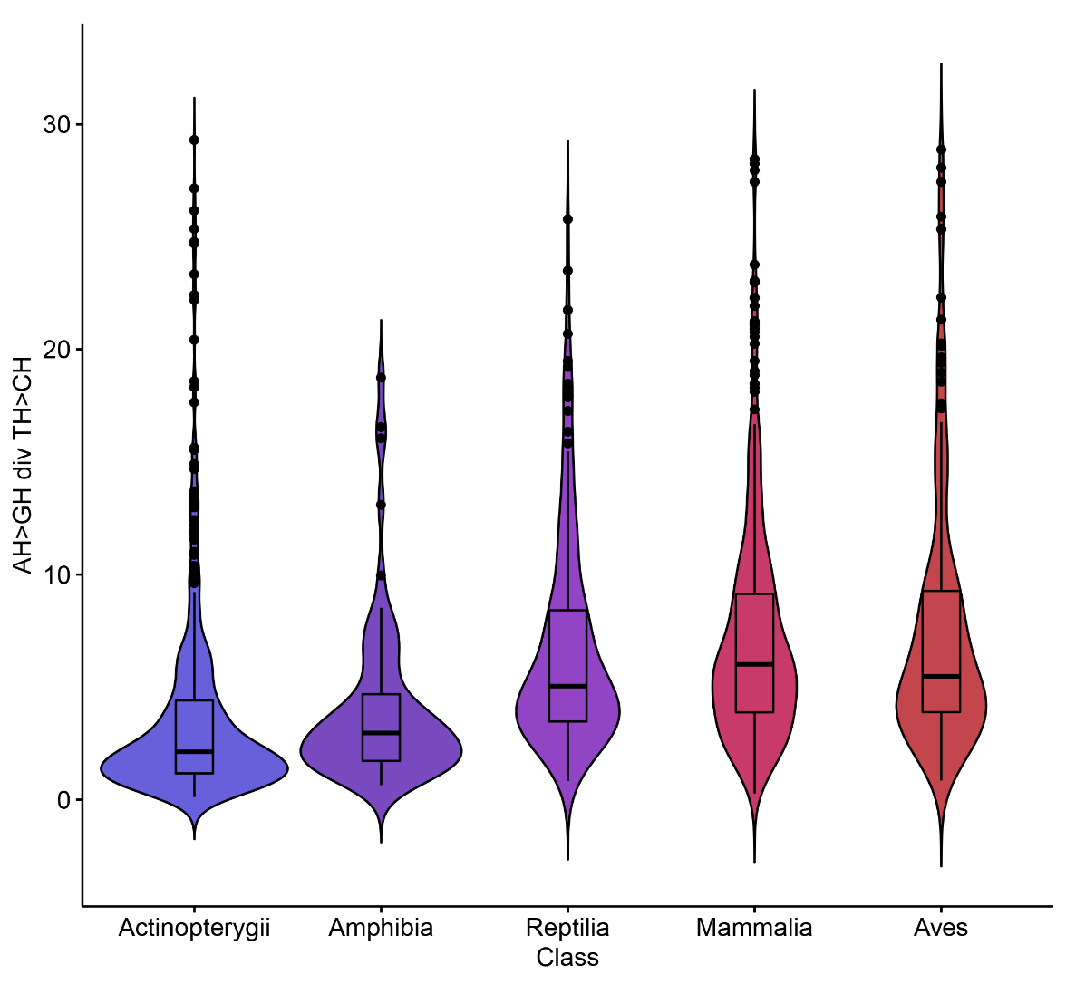**Average AH>GH/TH>CH in Vertebrate classes:**
   3. **A range of known mammalian body temperature:**

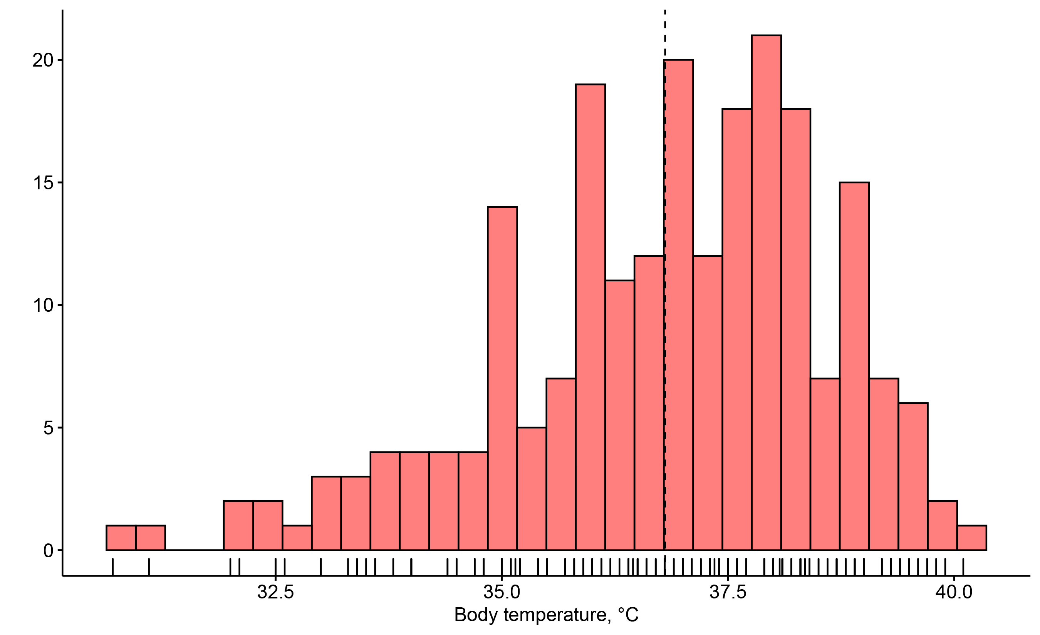

* 1. **Multiple model between STG-SAC skew and temperature + longevity:**

|  |
| --- |
| * lm(formula = AC_TGSkew ~ scale(Temper) + scale(GenerationLength_d),   data = allparameters)  (Intercept) 0.505937 0.006107 82.839 < 2e-16 ***  scale(Temper) 0.011729 0.006047 1.940 0.053679 .  scale(GenerationLength_d) 0.028182 0.007514 3.751 0.000225 ***  Residual standard error: 0.09029 on 221 degrees of freedom  (425 observations deleted due to missingness)  Multiple R-squared: 0.07463, Adjusted R-squared: 0.06626  F-statistic: 8.912 on 2 and 221 DF, p-value: 0.0001896 |

* 1. **Multiple model between STG-SAC skew and longevity + all cold groups (incl. cold species t**° **mean <36.8):**

|  |
| --- |
| * lm(formula = TG_ACSkew ~ log2(GenerationLength_d) + scale(allcolddummy), data = allparameters)   (Intercept) 0.314532 0.030680 -10.252 < 2e-16 ***  log2(GenerationLength_d) 0.018255 0.002761 -6.611 8.00e-11 ***  scale(allcolddummy) 0.017912 0.003106 5.768 1.25e-08 ***  Residual standard error: 0.07848 on 646 degrees of freedom  Multiple R-squared: 0.1192, Adjusted R-squared: 0.1164  F-statistic: 43.69 on 2 and 646 DF, p-value: < 2.2e-16 |

* 1. **Multiple model between AG skew and all cold groups (incl. cold species t**° **mean <36.8):**

|  |
| --- |
| * lm(formula = AtoGSkew ~ scale(Temper) + scale(GenerationLength_d), data = allparameters)   (Intercept) -0.19540 0.01201 -16.264 < 2e-16 ***  scale(Temper) -0.02751 0.01189 -2.313 0.0216 *  scale(GenerationLength_d) -0.09565 0.01478 -6.471 6.18e-10 ***  Residual standard error: 0.1776 on 221 degrees of freedom  (425 observations deleted due to missingness)  Multiple R-squared: 0.176, Adjusted R-squared: 0.1686  F-statistic: 23.61 on 2 and 221 DF, p-value: 5.103e-10 |

* 1. **Multiple model between fraction of A and all cold groups (incl. cold species t**° **mean <36.8):**

|  |
| --- |
| * lm(formula = FrA ~ log2(GenerationLength_d) + scale(allcolddummy), data = allparameters)   (Intercept) 0.326964 0.016474 19.848 < 2e-16 ***  log2(GenerationLength_d) -0.012105 0.001483 -8.164 1.70e-15 ***  scale(allcolddummy) 0.010043 0.001668 6.023 2.88e-09 ***  Residual standard error: 0.04214 on 646 degrees of freedom  Multiple R-squared: 0.1527, Adjusted R-squared: 0.1501  F-statistic: 58.21 on 2 and 646 DF, p-value: < 2.2e-16   * lm(formula = FrA ~ log2(GenerationLength_d), data = allparameters)   (Intercept) 0.338815 0.016796 20.173 <2e-16 ***  log2(GenerationLength_d) -0.013177 0.001512 -8.718 <2e-16 ***  Residual standard error: 0.04328 on 647 degrees of freedom  Multiple R-squared: 0.1051, Adjusted R-squared: 0.1037  F-statistic: 76 on 1 and 647 DF, p-value: < 2.2e-16   * lm(formula = FrA ~ scale(GenerationLength_d) + scale(allcolddummy), data = allparameters)   (Intercept) 0.193148 0.001694 114.050 < 2e-16 ***  scale(GenerationLength_d) -0.009939 0.001706 -5.825 9.03e-09 ***  scale(allcolddummy) 0.010528 0.001706 6.170 1.20e-09 ***  Residual standard error: 0.04314 on 646 degrees of freedom  Multiple R-squared: 0.1119, Adjusted R-squared: 0.1092  F-statistic: 40.7 on 2 and 646 DF, p-value: < 2.2e-16 |

* 1. **Multiple model between fraction of A and temperature + longevity:**

|  |
| --- |
| * lm(formula = FrA ~ scale(GenerationLength_d) + scale(Temper), data = allparameters)   (Intercept) 0.196165 0.003304 59.376 < 2e-16 ***  scale(GenerationLength_d) -0.021853 0.004065 -5.376 1.93e-07 ***  scale(Temper) -0.006774 0.003271 -2.071 0.0395 *  Residual standard error: 0.04884 on 221 degrees of freedom  (425 observations deleted due to missingness)  Multiple R-squared: 0.1306, Adjusted R-squared: 0.1227  F-statistic: 16.59 on 2 and 221 DF, p-value: 1.933e-07 |

* 1. **Multiple model between fraction of A and cold species (t**° **mean <36.8):**

|  |
| --- |
| * lm(formula = FrA ~ scale(GenerationLength_d) + scale(colddummy), data = allparameters)   (Intercept) 0.193148 0.001726 111.933 < 2e-16 ***  scale(GenerationLength_d) -0.010730 0.001731 -6.199 1.02e-09 ***  scale(colddummy) 0.006220 0.001731 3.594 0.000351 ***  Residual standard error: 0.04396 on 646 degrees of freedom  Multiple R-squared: 0.078, Adjusted R-squared: 0.07514  F-statistic: 27.32 on 2 and 646 DF, p-value: 4.058e-12 |

* 1. **Fraction of A versus longevity in mammals:**

